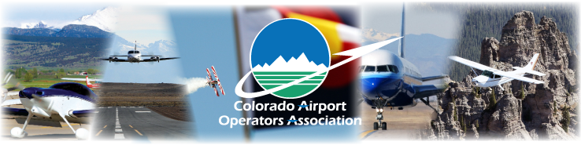

CAOA SPRING CONFERENCE
May 27-29, 2015

ANTLERS HOTEL
Colorado Springs, Colorado

AGENDA

Wednesday - May 27

9:00 – 3:00 PM GOLF OUTING Monument Hill Country Club

12:00 – 5:00 PM FAA/CAB/Airport Meetings Cameron

1:00 – 5:00 PM Exhibitor Set Up Summit I & II

5:30 – 7:00 PM Check-In/Registration Lobby

6:00 – 7:00 PM Welcome Reception Antlers Grille

Thursday – May 28

7:00 – 8:00 AM Breakfast with Exhibitors Pre-Function Area

8:00 – 4:00 PM FAA/CAB/Airport Meetings Cameron

8:00 – 8:15 AM Opening Welcome and Remarks Summit III
Honorable Local Dignitary - City of Colorado Springs

8:15 – 8:45 AM Unmanned Air Systems and Your Airport Summit III
Retired Colonel Stan Vander Werf – CEO Advanced Capital, LLC
Founder and Former CEO of UAS Colorado

8:45 – 9:15 AM Terrorism and Intelligence Sharing in the Air Domain Summit III
Robert P. Olislagers – Executive Director Centennial Airport

9:45 – 10:15 AM Exhibitor Break Summit I & II

10:15 – 10:45 AM General Aviation Update - Today’s Issues and Tomorrow’s Challenges Summit III Paul Meyers – Principal Aviation Management Consulting Group

10:45 – 11:30 AM The Missing Link in Safety: Personal Accountability Summit III
Doug Downey - Convergent Performance

11:00 - 4:30 PM FAA/CAB/Airport Meetings Carson

11:30 – Noon Exhibitor Break Summit I & II
Noon – 1:00 PM Lunch – Sam Gardner/Michael Musser/Kevin Stahley-MSU Students Summit III
Metropolitan State University of Denver’s Impact on Colorado Aviation

1:00 – 1:30 PM CDOT Update Summit III
Shailen P. Bhatt - Executive Director CDOT

1:30 - 4:30 PM FAA/CAB/Airport Meetings Carson

1:30 - 2:00 PM Crisis Communication Plan for Small Airports Summit III
(How I learned to stop worrying and love the Denver Post) Deborah Smith - Public Information Officer Centennial Airport

2:00 – 2:30 PM Legislative /Regulations Update – GA Airports AIP Funding Compliance Summit III
Daniel S. Reimer – DIA Assistant General Counsel

2:30 – 3:00 PM Blended Airspace Program “Next Generation Airport Traffic Control” Summit III
William E. Payne - Principal William E. Payne & Associates

3:00 – 3:15 PM Exhibitor Break Summit I & II

3:15 – 3:45 PM Legislative Update Summit III
Mickey Ferrell – Michael Douglas Ferrell, LLC
3:45 – 4:15 PM Wildlife Mitigation in Kuwait and Kandahar AFB, Afghanistan Summit III Kendra Cross, Dalin Tidwell & Doug Ekberg – USDA

5:00 – 5:30 PM Buses Leave for Evening Reception @ USOTC Hotel Lobby

5:30 – 8:30 PM Cocktail Reception and Facility Tour USOTC
UNITED STATES OLYMPIC TRAINING CENTER

8:30 – 9:00 PM Buses return to Antlers Hotel Hotel Lobby

Friday – May 29

7:00 – 9:00 AM Breakfast with Exhibitors Summit I & II

8:00 – NOON FAA/CAB/Airport Meetings Cameron

8:00 – 9:00 AM CAOA Board Meeting Board Room

9:00 – 9:30 AM CAOA General Membership Meeting Summit III

9:30 – 10: 00 AM Vendors Working with Airports and FAA Summit III
Bill Myslik – Brad Grose

10:00 – 10:30 AM AOPA Update Summit III
Dave Ulane – AOPA Regional Manager

10:30 - 11:00 AM FAA Update Summit III
John Bauer – Manager DEN ADO

11:00 – 11:30 AM Division of Aeronautics Update Summit III
CAB Representative

11:30 AM Conference Ends – See you at the Winter Legislative Conference in Denver - January 2016

www.coloradoairports.org

